**Competitive Shooters of Lake Norman USPSA October 9, 2025**

**COURSE DESIGNER:** Rocky Perillo

|  |
| --- |
| **START POSITION: See written stage briefings.** |

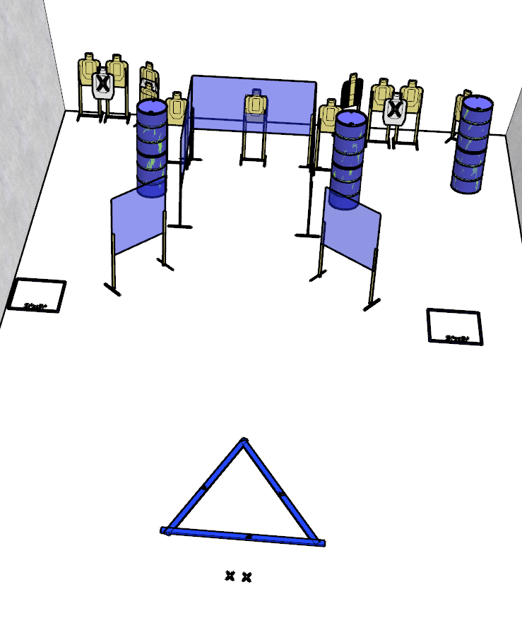

**Written Stage Briefing:**

**Stage 2 – There wolf -** is a 20-round, 100 point, Comstock Course. There are 10 cardboard targets and some noshoots. The best 2 hits per cardboard target will be scored.   
**Start position** Both feet inside any shooting area, facing directly downrange.

Handgun is **loaded** and holstered, wrists below belt.

PCC is **loaded** with stock touching belt.

On the audible start signal, engage targets from within the shooting area.